Name: | ___________________________________________________ |  | Date: ___________
 | Year 12 Mathematics: Applications  Investigation 3, 2017  Topic – Time Series  In Class Component
Total Time: | 60 minutes
Reading Time: | 5 minutes
Working Time: | 55 minutes
Equipment: | SCSA Formula sheets, CAS calculator, 1 page of notes
Weighting: 10% of the semester Marks: 50

Aim: The concepts and skills developed in this investigation relate to the following dot points
within the WA Mathematics Applications syllabus:

4.1.1 construct time series plots
4.1.2 describe time series plots by identifying features such as trend (long term direction), seasonality (systematic, calendar-related movements), and irregular fluctuations (unsystematic, short term fluctuations), and recognise when there are outliers
4.1.3 smooth time series data by using a simple moving average, including the use of spreadsheets to implement this process
4.1.6 fit a least-squares line to model long-term trends in time series data

Data smoothing

The two graphs below show details of the electricity accounts for one household at particular times from April 2012 to April 2015. The first graph shows the consumption (units used) and the second graph shows the costs incurred for the same household.

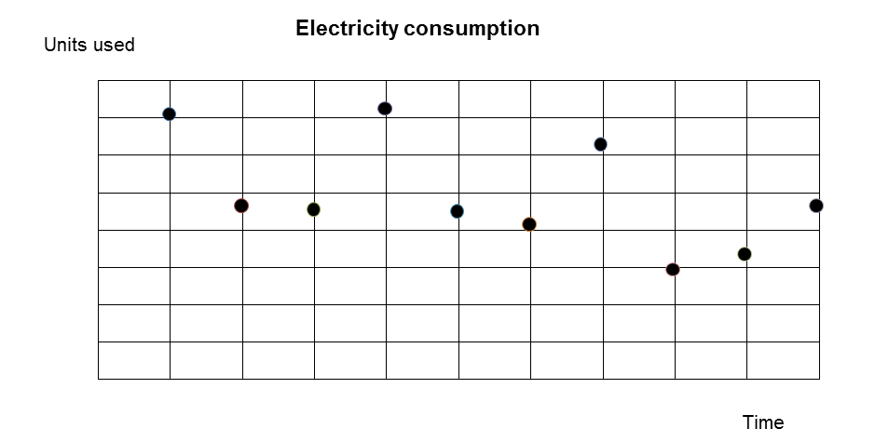
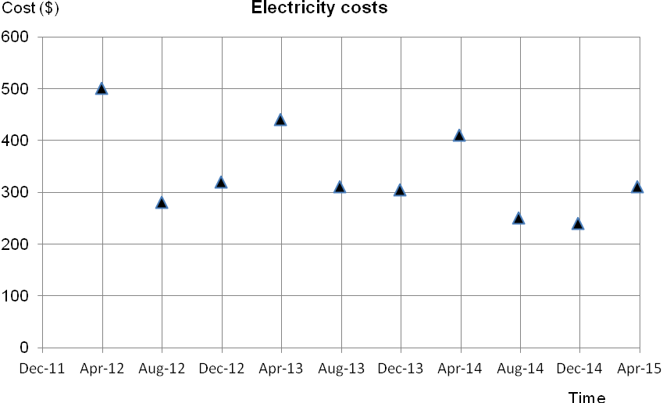

Question 1 (15 marks)

(a) Circle the data point representing the maximum cost for electricity during this period. (1)

(b) When did the household incur the maximum cost for electricity? (1)

(c) Draw triangles around the data points representing the minimum cost and the minimum consumption. (2)

(d) Give a reason to explain why the minimum cost has not occurred when the consumption was at a minimum. (1)

(e) How many times each year is the cost reported? (1)

(f) The costs rise and fall.
(i) At what time of year do the costs tend to be the highest? (1)

(ii) Give a reason to explain why costs might be the highest at that particular time of the year. (1)

(g) Describe the changes in electricity consumption from April 2012 until April 2015.
(3)

(h) There were two occasions when the couple living in that household went away for at least a month and the house was unoccupied. Identify one of these occasions and justify your answer. (2)

(i) Describe two pieces of evidence from these graphs that suggest the costs of the electricity depend on the consumption. (2)

Question 2 (14 marks)

When data rises and falls as in the case of the electricity costs it may be difficult to determine an overall trend. To see this trend “moving averages” are calculated. For the electricity costs, the moving averages are calculated as follows:
- The mean of the first three data points (points 1 to 4) is calculated.
(500 + 280 + 320) ÷ 3 = $367 (rounded)
- The mean of data points 2 to 5 is calculated.
(280 + 320 + 440) ÷ 3 = $347 (rounded)
- And the process is continued in this manner

The table shows some of the moving average calculations.

Time | Cost | Data point | Moving average calculations | Moving average
Apr-12 | 500 | 1
Aug-12 | 280 | 2 | (500 + 280 + 320) ÷ 3 | $367
Dec-12 | 320 | 3 | (280 + 320 + 440) ÷ 3 | C
Apr-13 | 440 | 4 | (320 + 440 + 310) ÷ 3 | $357
Aug-13 | 310 | 5 | A | $352
Dec-13 | 305 | 6 | B | D
Apr-14 | 410 | 7 |  | $322
Aug-14 | 250 | 8 |  | $300
Dec-14 | 240 | 9 |  | $267
Apr-15 | 310 | 10

(a) Determine the entries A, B, C and D for the table. (4)

(b) To show the trend graphically, the moving averages can be plotted on the same axes as the original data. The first data point is (Aug-12, 367) and the second is (Dec-12, 347).
Plot all the data points for the moving averages on the graph provided below. (4)

(c) Join the data points for

(i) reported electricity costs

(ii) and in a different colour or pattern, the moving averages (2)

(d) Draw a trend line “by eye” for the moving average data. (1)

(e) Describe the trend shown in the graph of the moving averages. (2)

(f) State one way in which the graph for the moving averages is different to the graph for the reported electricity costs. (1)

Question 3 (9 marks)

The trend line for the moving averages of the electricity costs, as described in the previous question, is given by

Moving average ($) = 388 – 12.5 x time

with time = 1 for Apr-12, 2 for Aug-12, 3 for Dec 12, etc..

The correlation coefficient = -0.91

(a) Predict the moving average for April 2015. (3)

(b) How reliable is your prediction of the moving average for April 2015?
Justify your decision about the reliability of your prediction. (3)

(c) Use the moving average from part (a) to predict the cost of electricity for August 2015.
Give mathematical justification for your prediction. (3)

Question 4 (12 marks)

The electricity consumption is shown on the graphs below. The first graph shows the recorded data and for the second graph the averages of the data points are plotted.
[These averages were calculated as in the previous question with the mean determined for each three data points]

A. Recorded data
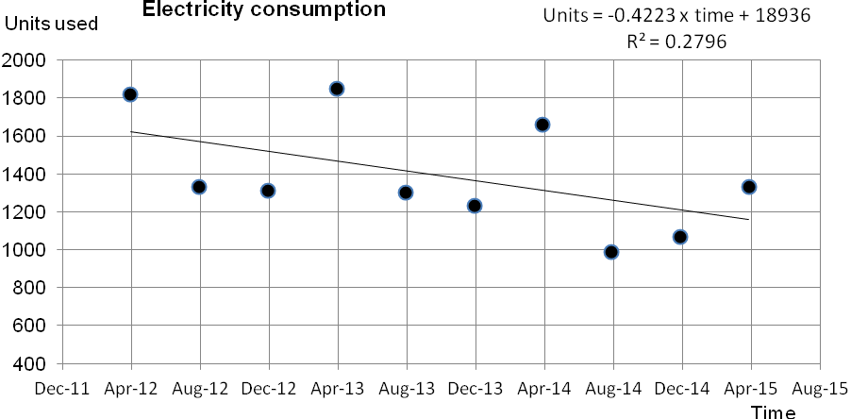

B. Moving averages
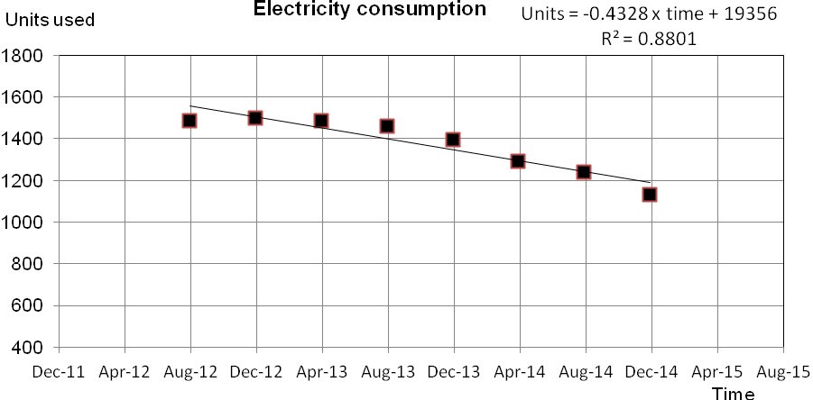

(a) Identify the response variable. Explain your decision. (2)

(b) The trend in consumption for both sets of data is negative.

(i) Describe one item of evidence to justify this conclusion. (1)

(ii) Describe the long-term outcome for this trend. Justify your decision. (2)

(c) Use the graphs of the trend lines to determine an estimate for

(i) recorded data for August 2015. (1)

(ii) a moving average for August 2015. (2)

(d) Comment on the reliability of the estimates determined in part (c). (4)
Justify your comments with evidence provided in this question.

End of questions

